|  |  |
| --- | --- |
|  |  |

Role Summary

**Job title:** Programme Manager (Lower Severn) with opportunity for extended Operations Team Lead role scope for an appropriate candidate.

**Location of job:**  Hybrid working - home based with regular travel requirements throughout the Lower Severn catchment.

**Post holder reports to:** CEO

**Salary:** £35,400 – £51,400 per annum (salary >£41,000 available only for candidates being considered for additional role scope.)

**Position type:** Permanent 

**Working arrangements:** Full-time (37.5 hours per week) or part time (min 3 days/week) with flexible working approach.

28 days Annual Leave **plus** bank holidays

Additional benefits: 9% employer pension contribution

A generous home working package, including mileage reimbursement from your home address plus monthly allowance.

Two additional days annual leave awarded after two years’ service.

**Overall purpose of the job:**

The Programme Manager role will join our expanding Operations Team, taking the lead on overseeing the coordination of a diverse portfolio of catchment restoration programmes, from floodplain restoration to woodland creation to agricultural advice to fish pass infrastructure projects.

You will oversee and coordinate an expanding team, with up to 5 direct reports. You will work closely with your team to support them in managing their individual projects, providing technical advice and general project management steer to ensure our programmes of work are delivered to a consistently high standard.

Alongside operational management, you will lead the development of our work in the Lower Severn, helping to design new programmes of work, unlock funding sources, establishing partnerships to support delivery, and engage new audiences with our work.

The role will be exciting, fast-paced and embed within a dynamic, close-knit team of like-minded professionals. You will have the potential for big impact and leave your mark on the recovery of Britain’s longest River.

For an appropriate candidate, there is an opportunity for us to consider an extended role scope that would sit within our Senior Leadership Team. Additional responsibilities would include strategic & financial oversight for our Operations Team, helping to determine the teams’ wider priorities, establishing common ways of working and, working alongside other Programme Managers to co-design Severn-wide programmes of work.

Our Challenge

The Severn is the longest river in the United Kingdom, stretching 220 miles from its source in the Cambrian Mountains in Powys Wales, through the counties of Shropshire, Worcestershire and into Gloucestershire to the iconic estuary. The culture and economies of the historic settlements across the catchment have been intertwined with the river through commercial navigation, fishing, water supply, and trade. Today, the Severn’s rivers, including important tributaries such as the Teme, the Stour and the Warwickshire Avon, continue to play an essential role in supporting wildlife, wellbeing and economies of the region.

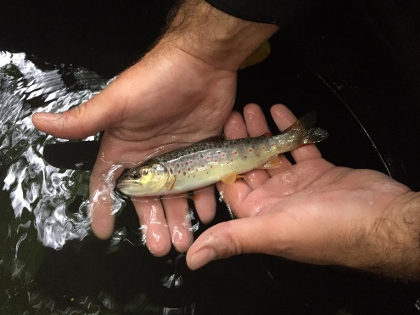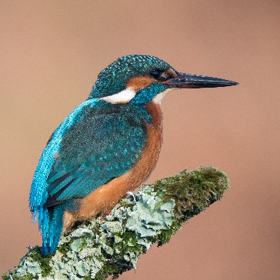

Our freshwater environments are in trouble like never before. The pressures are seemingly endless – sewage pollution, agricultural run-off, habitat loss and major weather events including drought and flooding are all threatening irreversible destruction of our freshwater ecosystems.

Despite the enormity of the challenge, it is not too late.

**Do you want to be part of the river Severn’s recovery?**

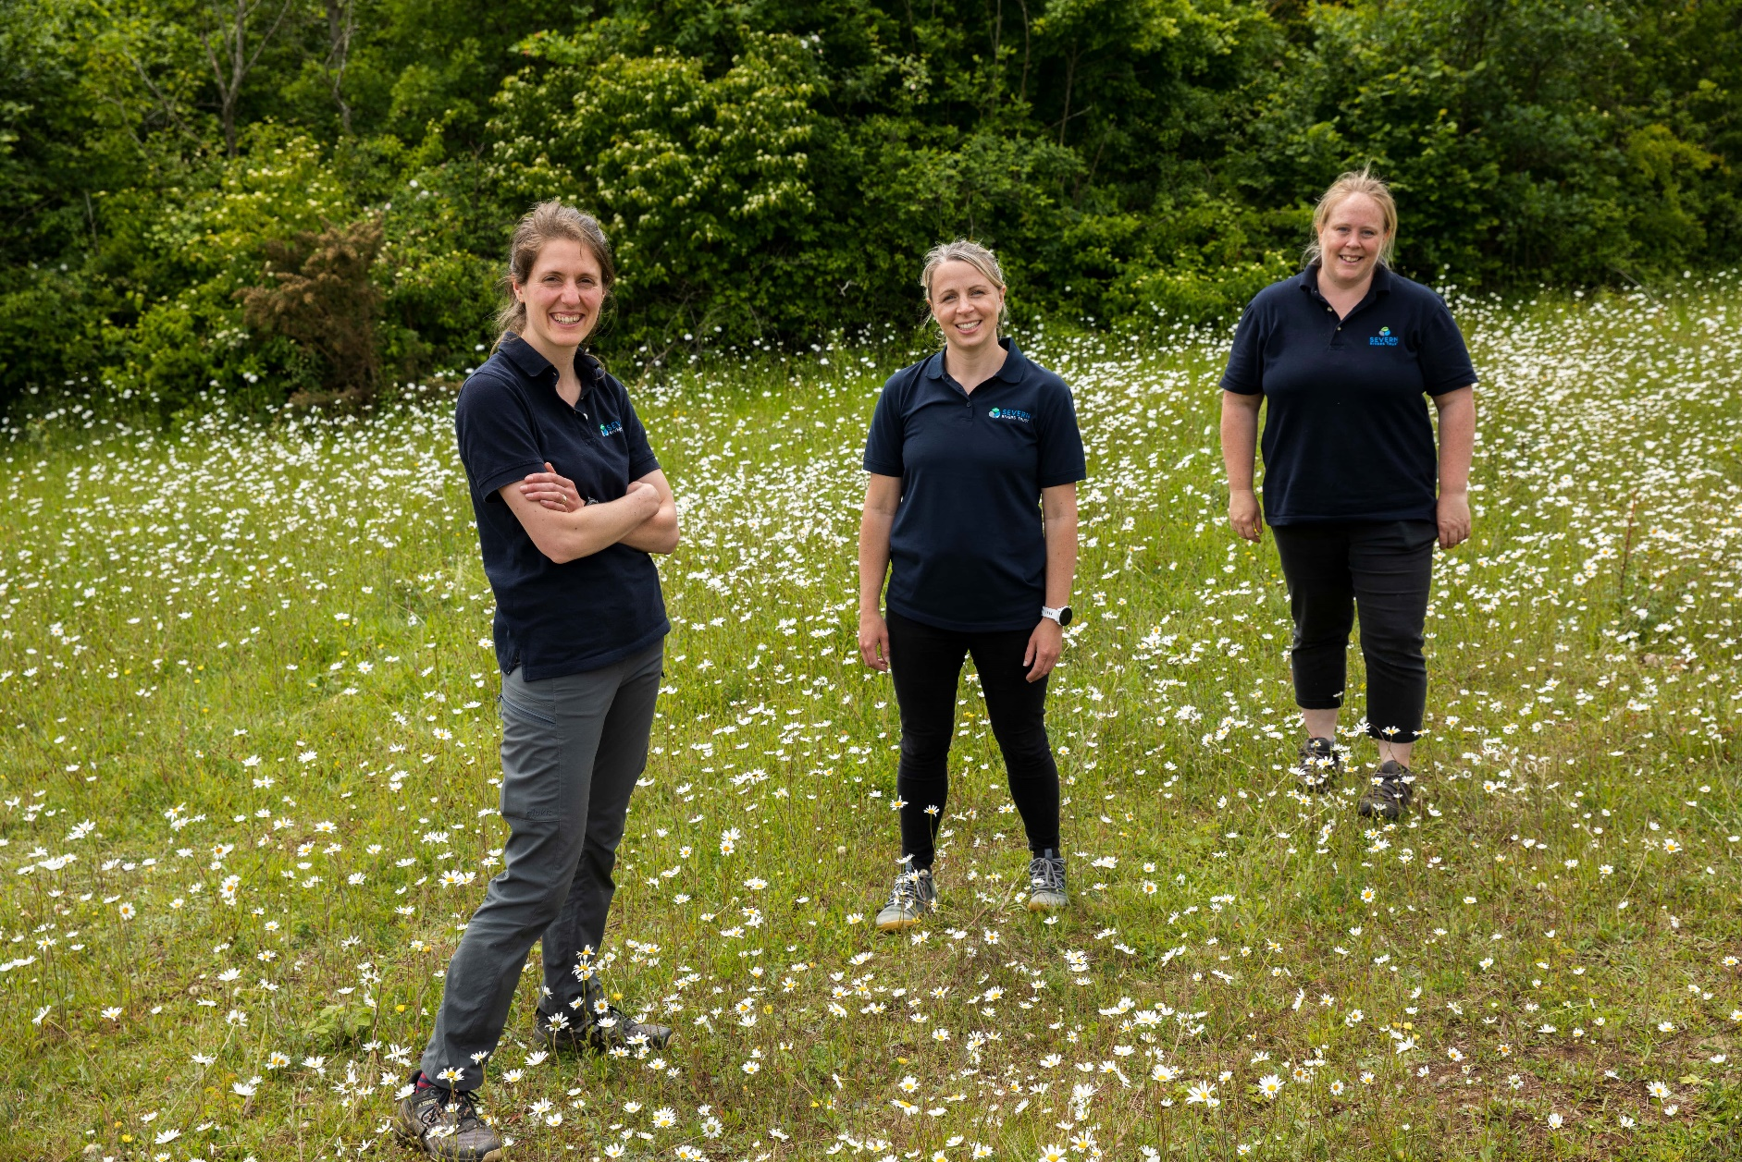**Our Team**

Our Team

Our work is organised across the following four divisions:

* Operations Team
* Development Team
* Community Engagement Team
* Finance and Administration Team

Our staff have an intimate understanding of the River Severn and its tributaries. We’re proactive and hands on, working with farmers, land managers and communities to deliver ecological restoration at a local level, with catchment-wide impacts.

Our mission is a healthy, resilient River Severn for everyone,and we strive to achieve this by delivering ambitious programmes of work across the following strategic themes;

* Restoring our rivers
* Removing barriers to fish migration to reconnect river habitat
* Renaturalising our rivers through works such as remeandering and installing woody debris.
* Recovering our land
* Advising farmers to encourage the adoption of regenerative agriculture practices.
* Restoring and creating habitat mosaics at a catchment scale including; wetlands, riparian woodlands, and floodplain meadows.
* Empowering our communities
* Mobilising volunteers to take action for their local water environment through citizen science monitoring and practical conservation opportunities.
* Establishing inspiring learning programmes to upskill and empower the next generation of river guardians.

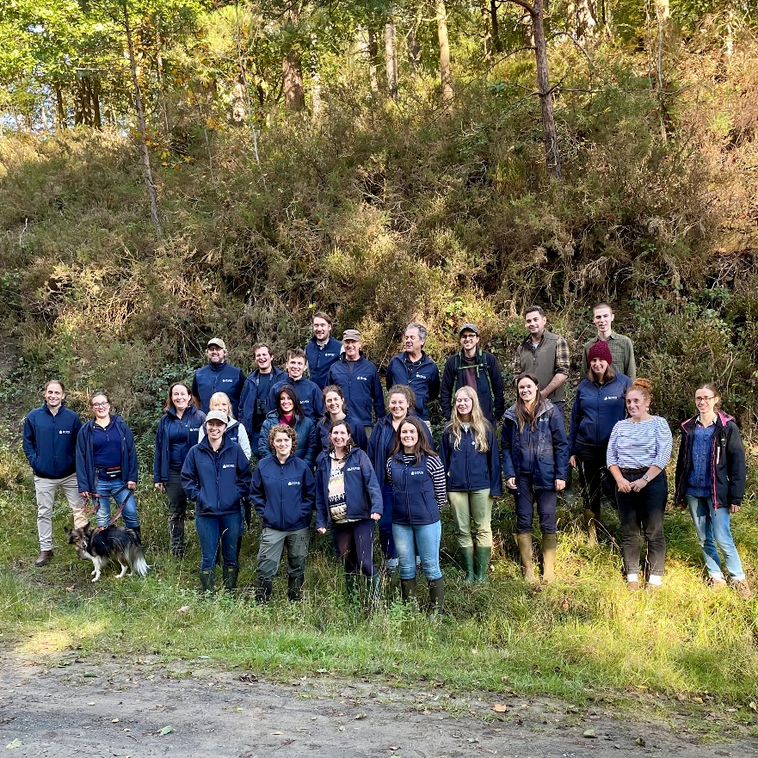

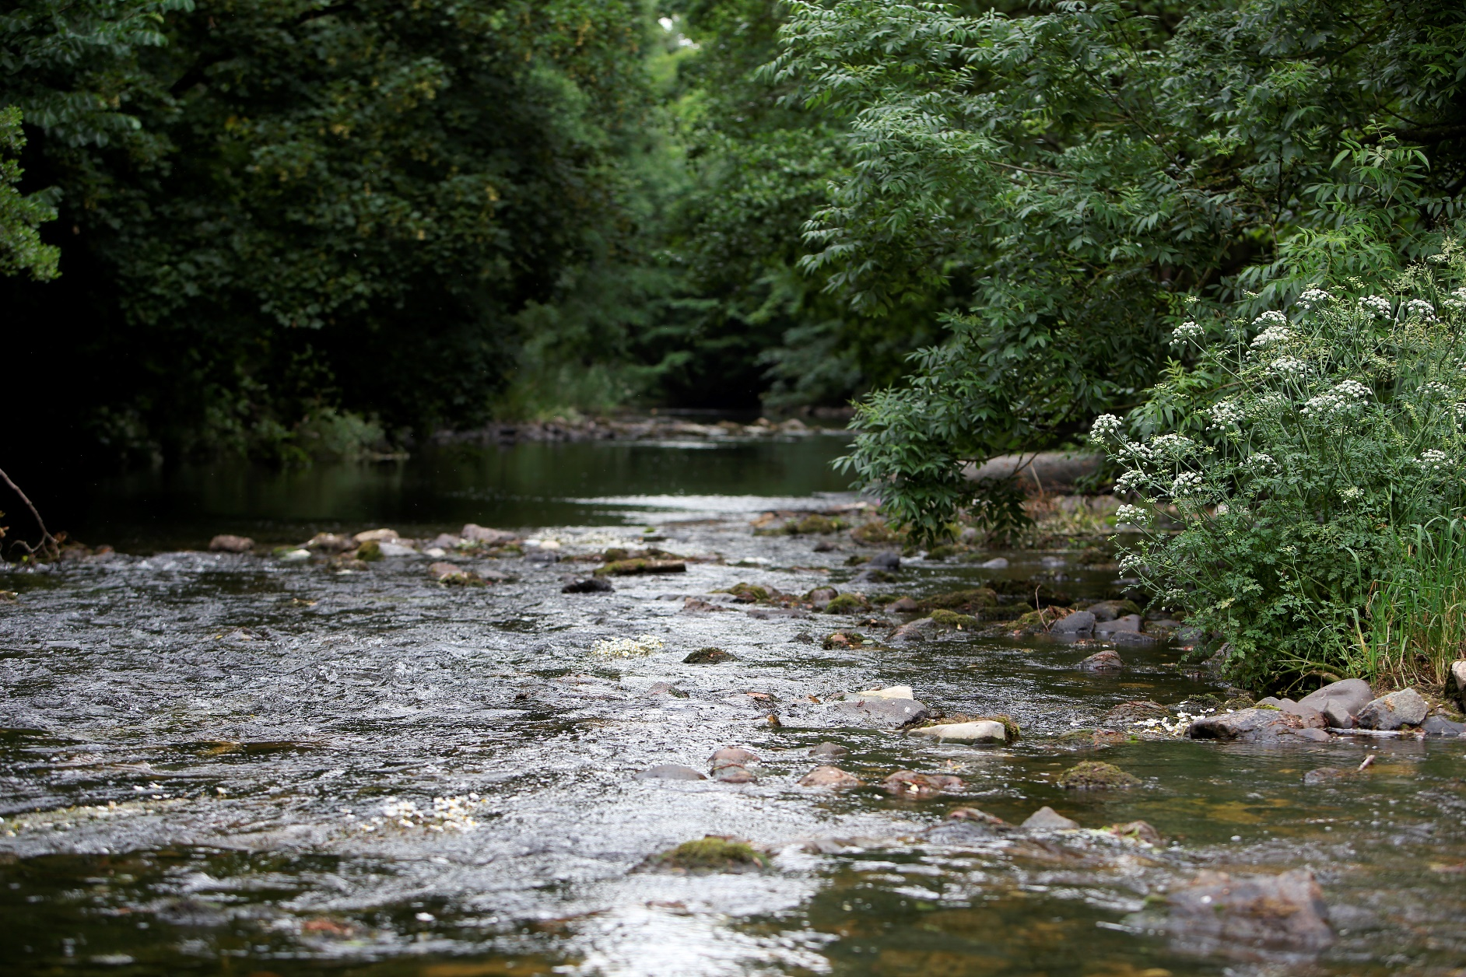

Our Working Area

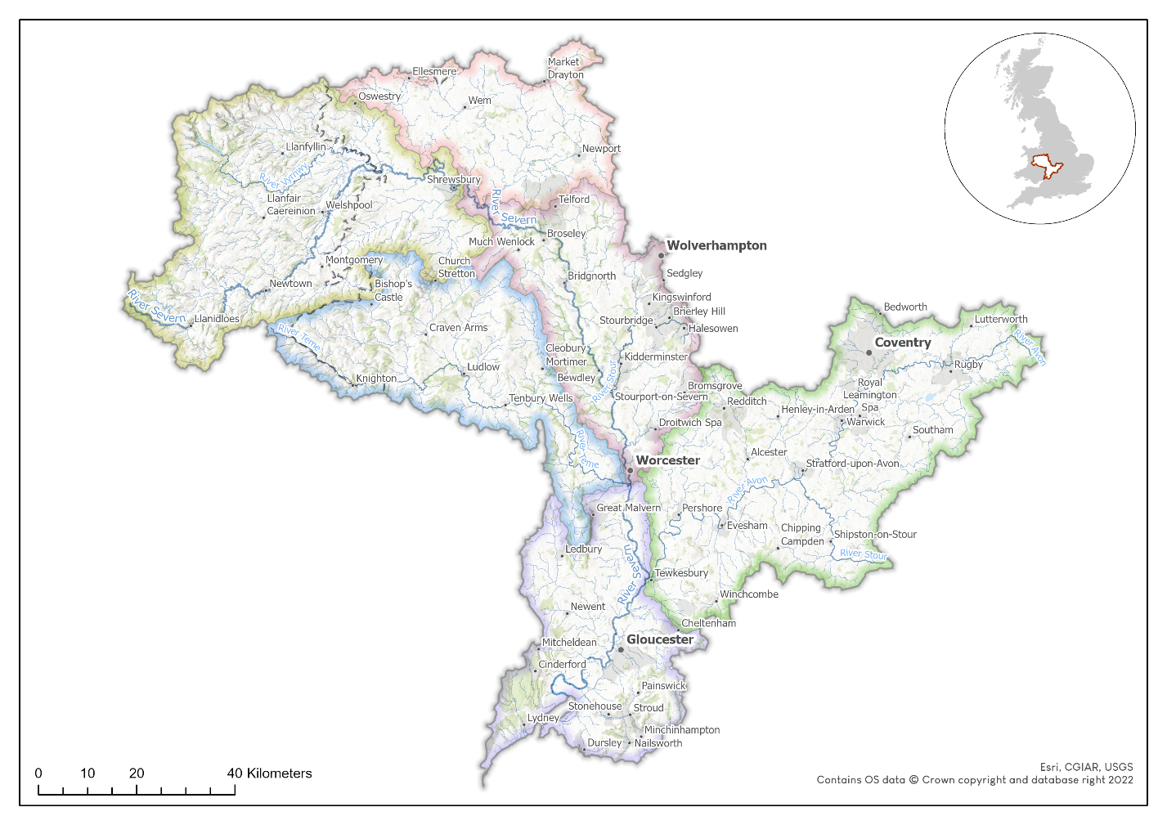

This position will be mainly operating throughout the Warwickshire Avon & Severn Vale catchments. Further information on the geography and catchment condition can be found by following the links below.

[Severn Vale Management Catchment | Catchment Data Explorer](https://environment.data.gov.uk/catchment-planning/ManagementCatchment/3077)

[Avon Warwickshire Management Catchment | Catchment Data Explorer](https://environment.data.gov.uk/catchment-planning/ManagementCatchment/3007)

Role requirements

**Team management**

* Manage the Lower Severn division of our Operations Team, with up to 5 direct reports, providing support and leadership to enthuse, motivate and empower the team.
* Support staff in managing multiple complex projects, by preparing work programmes that helps to plan work and manage delivery risks.
* Provide technical advice to aid the team’s decision making when delivering ecological recovery and land management advice programmes, to ensure we make the right decisions in the right places.
* Determine resource requirements, making decisions around how best to deploy staff resource, when to procure sub-contractors and when to recruit new staff, to service ever evolving workstreams by the most efficient means.
* Encourage innovation within the team, recognising good ideas and providing support to develop and refine them into new projects.

**Financial management & programme development**

* Financial oversight of the team’s work programmes, including budget forecasting, tracking and reprofiling, to ensure finances remain robust and resilient.
* Support your team in interpreting and managing their individual project budgets, giving them the autonomy and confidence to make financial decisions independently.
* Oversee the team’s grant claim requirements, preparing progress reports and supporting the Finance Team in collating evidence.
* Proactively develop new, innovative programmes of work and pursue funding for their inception, through grant applications, voluntary donations or securing private investment.

**Partnership working & collaboration**

* Proactively work to establish strong working relations with our stakeholders and partners and establish SRT as the ‘go-to’ delivery body.
* Represent and promote SRT at external events.

* Responsibility for coordinating one of the six Catchment Partnerships in the Severn Basin, working to bring together partners to share knowledge, develop ideas and encourage collaboration.

**Other Duties**

* Proactively follow developments in environmental policy to ensure the work of the team remains aligned with key legislative drivers.
* Lead by example in prioritising health and safety and wellbeing by taking responsibility for yourself, your team, and all those participating in our work.
* Support in establishing a workplace culture, where staff are motivated to come to work, capable of performing to their highest standard and comfortable being themselves.

Person specification

|  |  |  |
| --- | --- | --- |
| **Skills and Experience** | **Essential** | **Desirable** |
| Experience managing a team, with an ability to motivate, inspire and enthuse to achieve results | ü |  |
| Experience overseeing or delivering environmental programmes, such as habitat creation schemes or agricultural & land management advice | ü |  |
| An ability to identify issues affecting operational delivery and take measures to address them in a calm and professional manner | ü |  |
| Proven track record in securing funding for the successful delivery of environmental programmes | ü |  |
| Capable of independently managing and prioritising a demanding workload | ü |  |
| Experienced in budget management, including forecasting, tracking and reporting | ü |  |
| An effective, confident communicator, capable of engaging people and organisations with our work | ü |  |
| Experience of leading a safe working culture and a preventative approach to mitigate risks within their team. | ü |  |
| A good, broad understanding of environmental conservation and land management | ü |  |
| Experience working collaboratively as part of a management team | ü |  |
| A track record of successfully building a network of partnerships for collaborative working and fundraising. |  | ü |
| Experience of using finance software’s such Xero |  | ü |
| Further knowledge, skills, and experience in an area of specialism, such ecological restoration, agriculture, or land management |  | ü |
| Knowledge of nature investment markets and the opportunities available to the environmental sector |  | ü |
| Relevant degree level qualification |  | ü |

**Application process**

For further information or to discuss this post please contact Joe Pimblett, CEO.

**For emails enquiries:** [joe.pimblett@severnriverstrust.com](mailto:joe.pimblett@severnriverstrust.com)

**To chat or whatsapp:** 07730 559 128

Deadline for applications: **Midnight, Sunday 19th January 2025**

Interview date: **Week beginning 27th January 2025**

To apply for this role please forward a CV, with an optional cover letter to recruitment@severnriverstrust.com

Your CV should be no longer than 2 A4 sides and should present all of your relevant work history, education and training.

We will respond to all applicants with an email message to confirm receipt. Unfortunately, we cannot offer feedback to candidates who do not reach the interview stage.

**Thank you for your interest in the role with the Severn Rivers Trust.**

**Thank you for your interest in this role with Severn Rivers Trust!**